Feature Engineering
Preprocessing:
Fix distributions/skew
- Right skew
  - Log and square
- Left skew
  - Pain in the butt
  - (Max(x) + 1) -1)
    - Flip it, process like right skewed, flip it back (or don’t)
- Box Cox
  - The Box-Cox transformation is a preprocessing technique that transforms non-normal, skewed data into a closer approximation of a normal distribution 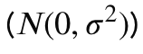 by finding an optimal exponent lambda
- Yeo Johnson
  - Modern, more flexible version of Box-Cox. GeeksforGeeks GeeksforGeeks +1 While Box-Cox is picky and only works if your data is all positive numbers, Yeo-Johnson has no such rules. It handles: Positive numbers, Negative numbers, Zero
  - For positive numbers: It acts just like Box-Cox (with a small tweak to include zero). For negative numbers: It uses a "mirrored" formula to smooth out the values on the other side of zero.
  - You use Yeo-Johnson for the exact same reasons as Box-Cox—to fix skewed data and make it look like a bell curve—but it is your "go-to" whenever your data contains zeros or negatives
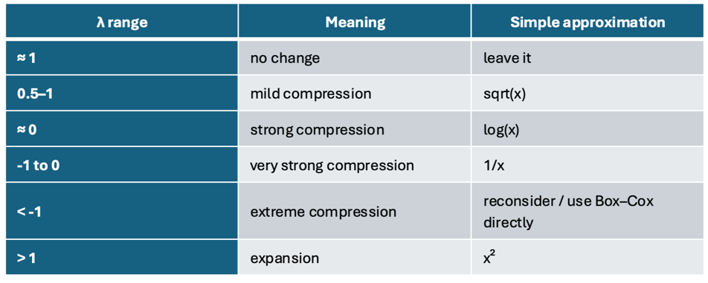
When should I transform?

Encoding categorical features
- Consider combining rare categories
- One hot encoding
  - Often default
  - Sparse data, many features
- Ordinal encoding
  - Only if true order
  - Model assumes distance between levels is meaningful
- Target encoding
  - Steps
    - Split train/test
    - Use folds
    - OOF (out of fold) averages
      - Never encode with observations own target
Imputing missing Values
- Sometimes ‘missingness” is a valuable feature to include. Ex(null vs nonnull)
- Simple
  - Numerical: mean/median
  - Categorical: “unknown”
- Train model to predict
  - Remove target before imputing
  - Don’t let it train with target value in there
    - Train/test
    - Train only with rows that have the feature
    - Impute train(missing) + test
Feature engineering
Interactions/ ratios (hereditary principle)
- Hereditary
  - Strong: keep the original features used to engineer a new feature (KEEP IT IN)
  - Weak: drop A or B
Clustering
- K-means clustering
Stacking/Ensembling
- Different models make different types of errors
- Once have features and have tuned, try combining models
Averaging of predictions from multiple models (or weighted average)
Meta-learner created using outputs from multiple models

